Pageant Eligibility & Rules

Application Packet You Turn In Must Have…  - Pageant Titleholder Application  - Contestant Agreement  - Eligibility Requirements  - Horse Health Form  - Contestant Agreement  - Liability Release Waiver  - Equine Assumption of Risk Agreement | - Photocopy of Birth Certificate  - Photocopy of Driver's License  - Photocopy of Voter's Card  - Program Sponsorship Forms  - Auction Items  - Sponsorship Funds

ELIGIBILITY
- Miss contestants must be 18 by the time they submit their application for Miss Livingston Roundup and cannot be older than 24.
- All contestants must be legal residents of Montana, by January 1st of the competition year.
- All contestants must be single females (not married — boyfriends are allowed), must never have been married or pregnant, and must agree to remain so for the duration of her reign if she wins.
- All contestants must be a natural-born female and identify as a female.
- All contestants must never have been charged and/or determined to have committed any crime of moral turpitude, convicted of any offense, (other than minor traffic offenses) nor have had a previous title removed for any reason.
- All contestants must grant permission to the Miss Livingston Roundup Committee to verify any information contained on the official pageant application and supporting documents.
- All contestants must have a western wardrobe for all pageant functions.
- All contestants must agree to abide by these and all other pageant rules, recognizing the possibility of disqualification for infractions thereof.
- Contestants must not have held a state title of any other national pageant.

APPLICATION REQUIREMENTS
- All contestant applications are due on the date determined and listed each year - to be printed out and handed in at the said date determined and advertised.
- All contestants must supply a printed copy of their birth certificate. It is required for entry into the Miss Rodeo Montana and Miss Rodeo America Pageant, therefore we require it too.
- Program Sponsorship and Auction Forms are also due at the Welcome meeting along with donations — if they are gift cards, please print them out on nice paper or email them to us.
POTENTIAL TITLEHOLDER REQUIREMENT
- All contestants and gaurdianmust be willing to sign an agreement for her reign and abide by its rules if she wins.
- All contestants must have executed all consent forms and/or waivers of liability presented as conditions precedent to competition.
- The pageant winner must have a horse available to her for her year of reign if needed.
- All contestants must also have reliable transportation, adequate liability insurance, and medical insurance, and will need to provide proof of insurance. She must be able to travel to local rodeos in our pageant area.
- All contestants must understand that, in the event of winning the contest, she will work closely with the Miss Livingston Roundup Committee, and that fundraising is a necessary part of the title.
- The pageant winners may not compete in and otherwise participate in any other beauty and/ or talent contest, pageant and/or activity,
- The pageant winners may not solicit, negotiate, or contract with any third person for an appearance, photographs, interviews, sponsorships and/or endorsements during the year of her reign without discussing it with the Committee. Pageant winners will not take any actions, which in the good faith determination of the MLR Committee, will or are reasonably likely to cause harm or damage to the goodwill or reputation of the Livingston Roundup and its pageant.
- Will not violate any provisions of the participation agreement, any other pageant agreements, or pageant rules and regulations.

GENERAL RULES
- Judges have the final say on all scoring decisions.
- Contestants must be prompt and on time for all functions. Please plan ahead. Tardiness is not tolerated.
- This Pageant is held under LRA Committee rules, with guidance from the Miss Rodeo Montana and America Pageant and Livingston Roundup Association. Provided that all agreement provisions are met throughout the year, the contestant chosen as Miss Livingston Roundup will attend our PRCA rodeo, local rodeos, close PRCA events, appear in parades, at Kiddie Rodeos, and other civic and social activities as necessary. Titleholders may attend NRA Rodeos, other PRCA rodeos not mentioned above, and other events with prior approval from the MLR Committee.
- Miss Livingston Roundup will have her entry fee into the Miss Rodeo Montana Pageant after her year representing the Livingston Roundup through the Miss Livingston Roundup Association.
- The incoming Miss must immediately sign an agreement covering her reign. Parent(s)/ guardian(s) must understand that this agreement is between the MLR Committee and the contestant who wins the title of Miss Livingston Roundup. While we encourage parental participation and input into her reign, it should be understood that parents are not included in the agreement. Any issues will stay between the MLR Committee and the Titleholder only.
- Formal grievances must be submitted in writing to the Committee within 30 days of the Pageant.
- Miss Livingston Roundup Committee holds all rights for promotional, television, radio, and photographic materials involving the Titleholders and contestants. Publicity and photo use must be approved by the Committee in advance. Use of the Miss Livingston Roundup name, logo, or position must be approved by the Committee.
- Appropriately conduct yourself at all times. There may be silent judges present.
- The pageant dress code, included in the rulebook, will be strictly adhered to for each event.
- Contestant expenses during the pageant including room and board will not be provided by Miss Livingston Roundup. Contestants must bring with them any incidentals and/or personal care items that they may need. Please plan ahead. Contestant banners are provided.
- Family members, friends, and others are not allowed in the pageant judging areas unless specified.
- Parent(s)/guardian(s) and relatives are encouraged to attend! Miss Livingston Roundup welcomes all and wants to make this an enjoyable time for everyone involved. However, parents/guardians, relatives, friends, coaches, etc. may not interfere with the judges in any way. Interference may cause the contestant’s disqualification.

GENERAL RULES
- There will be no use of ANY alcohol or tobacco product by any contestant during the pageant. Doing so will be grounds for immediate disqualification.
- Miss Teen will also not be permitted in any bars or marijuana establishments outside of an approved official LRA event or meeting.
- MLR Committee will not provide transportation for any of the contestants. Contestants and families must provide their own transportation.
37.Auditor: A CPA firm will tabulate the official judges’ score sheets. The Head Judge will deliver sealed results at the end of each day’s events. Following the pageant, each contestant will receive a tabulation of her scores and rank in each category, as compared with the winner of each category. This should be used for educational purposes to improve for the future pageant.
- If a contestant chosen as a Titleholder is not able to fulfill her duties as deemed by the Committee, that Titleholder must return any awards and make compensation for any monetary awards received, and all future appearance dates will be canceled. The Committee reserves the right to determine if a successor will be named, and if so, who that will be.
- Contestants will be under the supervision of the pageant chaperon or chaperones from the time the pageant officially starts until the end of the day each day. Chaperones will escort the contestants to and from all functions during the pageant. They are not babysitters but are available if you need something or have a question. Committee members and pageant organizers may be of assistance as well.
- From the time the pageant starts until after coronation, contestants must obey the pageant rules and Committee and appropriately conduct themselves. Any contestant failing to do so will be automatically disqualified, forfeit any prizes and all prizes won and gifts received at the pageant, and is ineligible to enter a future Miss Livingston Roundup Pageant.

JUDGING DIVISIONS
Judging will be conducted in four categories: Horsemanship, Appearance, Personality, Projection/Presentation, and Horsemanship Exam. Categories are each worth 20% of the contestant's score. In addition, each contestant’s written test score will be added to her total score. There will be three judges who will judge all four categories. Each contestant will have the same opportunity to be judged informally, in formal interviews, during luncheons, speeches, and horsemanship competition, and any other activities deemed appropriate by the pageant committee or judges.
Careful consideration will be taken by the pageant committee to choose judges with expertise in all fields of the competition. In the event of a tie in any of the categories or for total points, the award will go to the contestant with the highest written horsemanship test score. If a tie still exists, the award will then go to the contestant with the highest total score of the Projection & Presentation Category.

HORSEMANSHIP RULES
The purpose of the Horsemanship Award is to select the young woman who scores the highest in all scores that fall within the Horsemanship Category.
- Judges will select one of three patterns below for the Miss.
- Horsemanship competition will consist of two go-rounds. One pattern chosen by the judges from the included below and one round of rail work.
- Horses and tack will not be supplied. You must bring your own horse.
- Contestants may also be asked to execute a queen buzz, mount, dismount and/or carry a flag at the discretion of the judges, following ANY of the horsemanship patterns.
- The understanding and skill of the contestant will be judged—not the horse or the equipment.
- The judges will score the “degree of difficulty” of your ride, to take into account the difference in training level of the horses.
- No spurs or chaps permitted.
- Any changes and/or alterations to the horsemanship patterns will be announced to the contestants before the horsemanship competition begins.
- In rail work, each contestant will follow the announcer’s commands to show the horse to the best of her ability.
- Judges will be looking for showmanship ability, balance-ability to sit a saddle, control of mount and the way any situation that may occur is handled, and positions of hands, feet, and seat.
- The patterns will be demonstrated by the reigning Titleholders, before the contestants perform, respectively.
- The Judges reserve the right to make alterations and/or additions to these instructions.
- In Horsemanship Interview, the contestant must have knowledge to cover general horsemanship, tack, horse anatomy, basic veterinarian knowledge, professional rodeo, current PRCA & WPRA standings, AQHA issues, etc.
The contestant with the highest total score of the horsemanship category will be recognized as the horsemanship winner.

PATTERN #1
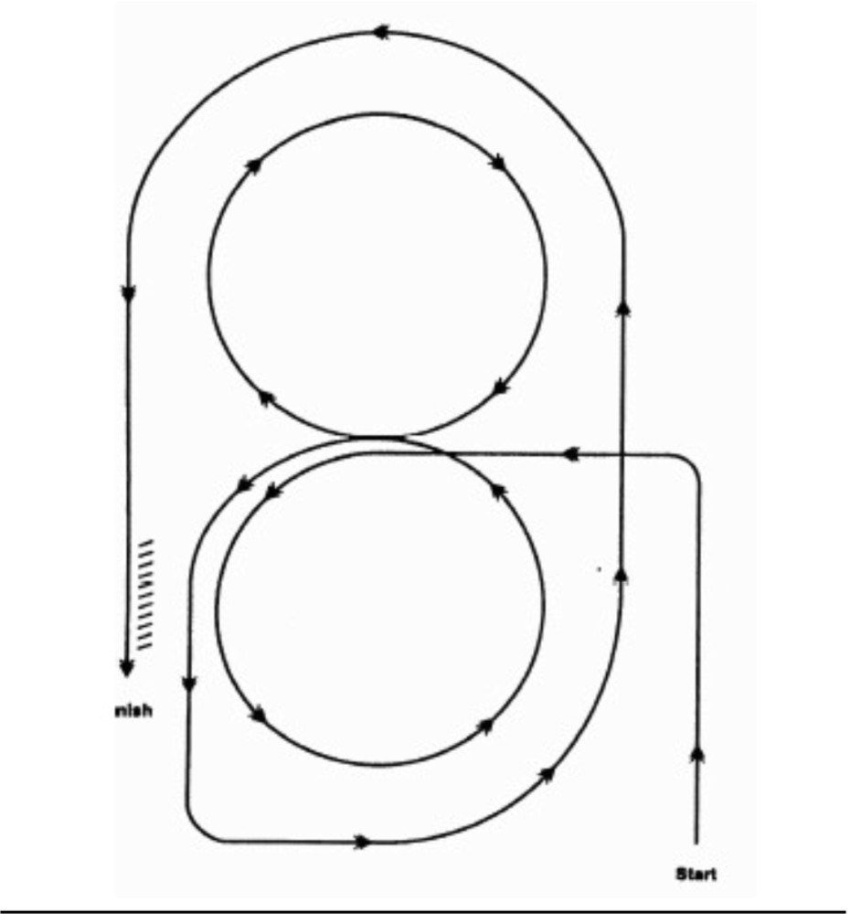
- Do extended jog alongside side of arena, then to center.
- Begin lope at center of arena and lope left circle on left lead.
- Change leads at center of arena and lope right circle on right lead.
- Change leads and continue loping around end of arena.
- Once back on the straight, increase speed and continue around end of arena.
- Stop and back horse 10 steps.

PATTERN #2
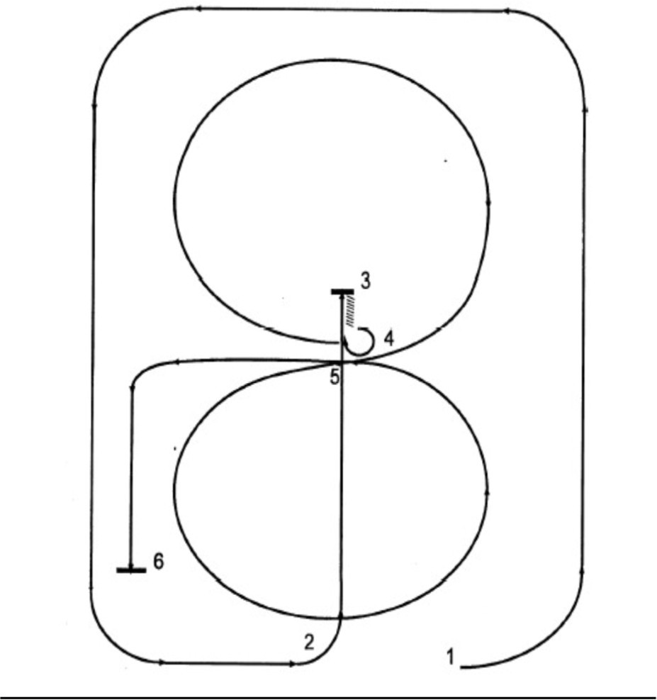
- Circle the arena, on the left lead, at an extended lope.
- Guide left and lope down the center of the arena with moderate speed.
- Pass the center of the arena, stop and back to the center.
- Execute a 3/4 turn to the right and lope a circle, to the right, with moderate speed.
- Change leads and lope a circle, to the left, with moderate speed. After completing the circle, continue loping on the left lead toward the end of the arena.
- Stop and pause to show completion of pattern.

PATTERN #3
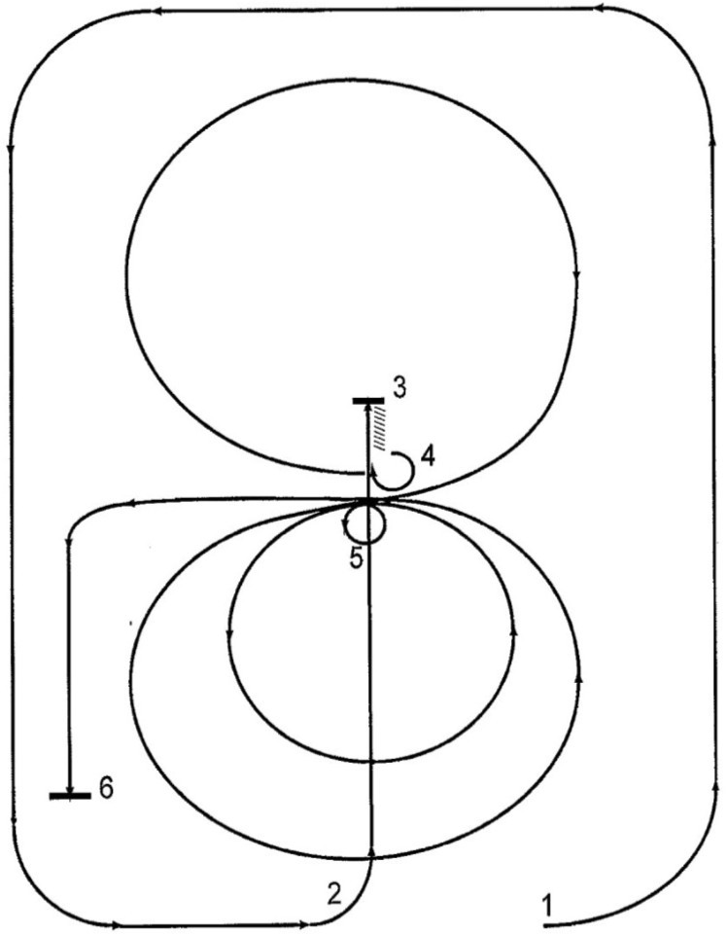

- Circle the arena, on the left lead, at an extended lope.
- Guide left and lope down the center of the arena with moderate speed.
- Pass the center of the arena, stop and back to the center.
- Execute a 3/4 turn to the right and lope a circle, to the right, with moderate speed.
- Stop in the center, execute a 360 degree turn, to the left. Lope a small slow circle, to the left, followed by a larger, faster circle to the left. At the center of the arena, rate back to the slower speed and continue loping on the left lead toward the end of the arena.
- Stop and pause to show completion of pattern.

APPEARANCE RULES
The purpose of this award is to select the young woman who scores the highest in all scores that fall within the Appearance Category.
- Grooming is most important as our Titleholders represent the professional sport of rodeo. Each contestant must have neatness about their appearance, and cleanliness is expected in every detail such as complexion, hands, hair, nails, fragrance, and clothing.
- Wearing apparel is important in this pageant but is not what will win you the title. Clothing does not need to be expensive but should be clean, fit well, coordinate, and free of holes. Contestants should demonstrate knowledge of current fashion trends in western wear through their choice of attire.
- Individuality, imagination, versatility, creativity, and how the contestant presents a complete image will all be taken into consideration.
- Western hats must be worn at all pageant functions; no straw hats are permitted.
- Banners will be provided and must be worn correctly at all pageant functions.
- Judges will be looking for versatility and imagination displayed by the contestants.
- Contestants are encouraged to utilize outfits at more than one event.
The contestant with the highest total score in the appearance category will be recognized as the appearance winner.

PERSONALITY RULES
The purpose of this award is to select the young woman who scores highest in all scores that fall within the Personality category.
- The personality that you project during your performance.
- Social situations/general ability to present herself to people in a positive manner.
- Conversational ability with grammar and proper use of English in various contexts.
- Appropriate common sense.
- Genuine interest in other people and noticeable courtesy and diplomacy in all situations.
- The ability to present herself graciously with maturity, high moral standards, sincerity, and integrity.
- Have a happy outlook on life, a general sense of humor, and the ability to adapt to most situations.
- General ability to handle herself in situations that require maturity and leadership while maintaining a genuine ability to relate to the grassroots people of rodeo.
- Promptness in keeping the pageant schedule.
- A personality interview will be conducted by the judges.
The contestant with the highest total score of the personality category will be recognized as the personality winner.

PROJECTION & PRESENTATION RULES
The purpose of this division is to select the young woman who scores highest in all scores in the Projection & Presentation Category including:
- Speaking Ability: Judging will be based on your ability to speak to an audience, prepare a presentation, and deliver it with poise and confidence.
- Media Question - your responses are included in this category. The media question can be anything that has been in the news over the past year.
- Conversational ability is included in this category.
- Personality Interview responses will be judged under this category. Personality Interview should cover your intelligence and knowledge of current events. Contestants should be aware that the judges will be asking a variety of questions, and it should be expected that many of the questions will have some depth so judges may determine the character and knowledge of each contestant.
- The speech competition will consist of an Extemporaneous Speech and Media Event.
  - Extemporaneous Speech—Each contestant will choose one of the prompts and prepare a speech to deliver to the crowd. Judging is based on content, delivery, and the time allotted for the presentation. Speech Length Requirement 90-120 seconds
  - Media Question—The media event will be live. Judging is based on knowledge, poise, professionalism, and delivery.
The contestant with the highest total score in the projection and presentation category will be
recognized as the projection and presentation winner.

MISS LIVINGSTON ROUNDUP PAGEANT DRESS REQUIREMENTS
Appearance is very important, but it is not necessary to invest in an excessive amount of expensive clothing or to have a different outfit for each event. You are not judged on the number of outfits you have nor if they are handmade or designer label, leather or cotton. What is important is for you to be clean, neat, and comfortable to present your style, and to be confident. By studying the judges’ score sheet summary included in this packet, you can see for yourself which events are important for appearance. At the Coronation, we recommend you wear your speech outfit again. Bobby pins to secure your hat are recommended, and hair should be properly styled for all occasions. Helmets are not considered traditional attire but may be worn if desired.
HORSEMANSHIP:
Wrangler Jean pants; fitted blouse or shirt with long sleeves—any color. Embellishments allowed. No jackets or vests. Any color accessories (hat, boots, belt) may be used. Gloves are optional. Chaps & spurs are not allowed. All riding attire should be neat and fit.
WESTERN CASUAL:
Jean pants and collared blouse. Vests or jackets are permitted. Sleeves must be 3/4 length or more.
WESTERN ELEGANCE:
Dress or skirt outfit; must be western styled, 3/4 length sleeves or longer. Split skirts in good taste. No prom-style dresses. The bottom of the skirt or dress must at least touch boot tops (or longer).
WESTERN BUSINESS
Professional business style dress or pantsuit. It can be long or short - no more than 3” above knee.
WESTERN TRENDING (FASHION SHOW):
Western fashion-forward outfit. Something you wear to George Strait’s house for a dinner party.
RODEO:
Western outfit. Jean pants and a long-sleeve shirt appropriate for arena wear.
WITH ALL OUTFITS:
Western Hat | Cowboy boots | No fashion heels | No lace-up boots
No Straw hats | No cleavage; nothing bra-less. | Proper slips under skirts/dresses. | 3/4 sleeves or longer  (unless otherwise noted)
Skirts/dresses maybe be no shorter that 3” above the knee | No ropers with skirts/dresses | Belt and buckle must be worn. | Contestant Banner (will be provided for you)
13

MISS LIVINGSTON ROUNDUP

Judging rubric
Event | Appearance | Personality | Horsemanship | Presentation & Projection | Total Per Judge | Contestant’s Final Score
Photogenic | /20 | /10 |  |  | /30
Introduction | /15 | /15 |  | /20 | /50
- Media Question | /15 | /15 |  | /30 | /60
Personal Interview | /15 | /40 |  | /30 | /85
Speech | /45 | /30 |  | /40 | /115
Modeling | /45 | /30 |  | /30 | /105
Horsemanship | /30 | /10 |  |  | /40
Pattern |  |  | /60 |  | /60
Pattern Degree of Difficulty |  |  | /10 |  | /10
Rail work |  |  | /60 |  | /60
Rail Work Degree of Difficulty |  |  | /10 |  | /10
Presentation Run wave/flag |  |  | /30 |  | /30
Lunch w/ Judges |  | /20 |  | /20 | /40
Horsemanship Interview | /15 | /30 | /30 | /30 | /105
Coronation | 0 | 0 | 0 | 0 | 0
Horsemanship Written Test |  |  |  |  | /200
Grand Total | /200 | /200 | /200 | /200 | /1000 | /3000
13

